Lecture 2 – Theory of Computing – Natural Deduction

Natural deduction:

Assumption equation:

Conjunction equations:

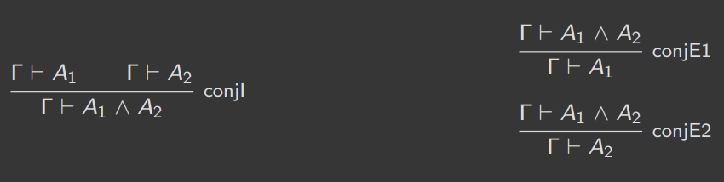

Conjunction is commutative:

Disjunction:

Implication:

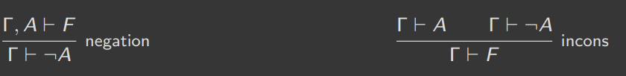

Negation:

Truth:



Falsehood:

Classical (decidable) logic:

Example (transitivity of implication):

